How to separate the date time field to date, time and hour | 

Question:
Sometimes the date in analytics has the full calendar date plus the time. For example the ‘Last Loan Date’ in the ‘Physical Item Details’ dimension of the ‘Physical Items’ subject area. How can we get just the date (without the time) to filter or display? Sometimes we also need just the time, or hour.

Here is how it appears now:

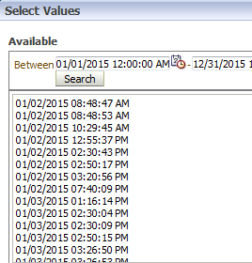

Short answer:
In ‘edit formula’:
The date: CAST("Physical Item Details"."Last Loan Date" AS DATE)
The time: CAST("Physical Item Details"."Last Loan Date" AS TIME)
The hour: HOUR(CAST("Physical Item Details"."Last Loan Date" AS TIME))

Full answer:

ONE
The CAST function (among other methods) can be used for this.
First choose ‘edit formula’ on the desired field from the criteria tab

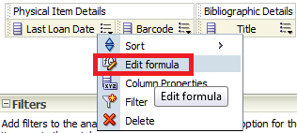

TWO
Click ‘Insert Function’

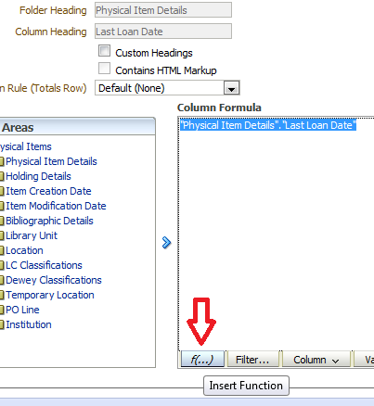

THREE
Choose “Conversion > Cast’

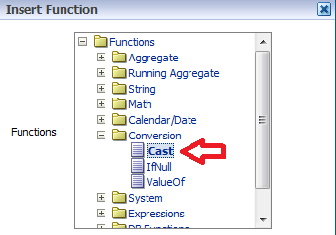

FOUR
Get this:

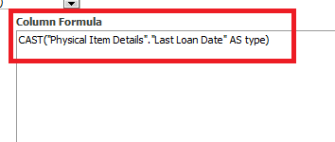

FIVE

To get the time change
CAST("Physical Item Details"."Last Loan Date" AS type)
To
CAST("Physical Item Details"."Last Loan Date" AS TIME)

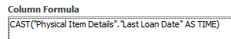

And if desired change header

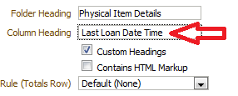

SIX
Now it appears as follows:

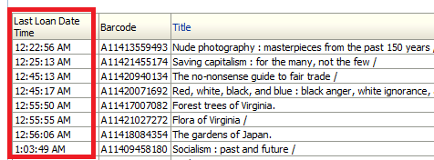

SEVEN
To get just the date do
CAST("Physical Item Details"."Last Loan Date" AS DATE)

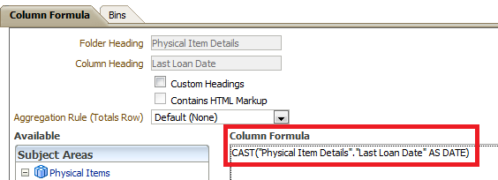

EIGHT
It now appears like this:

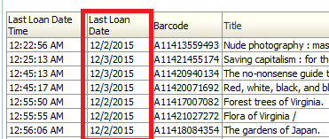

NINE
To get just the hour do
HOUR(CAST("Physical Item Details"."Last Loan Date" AS TIME))

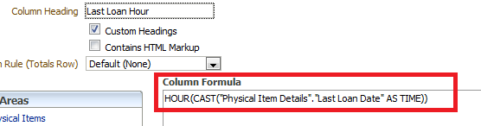

TEN
It now appears as follows:

